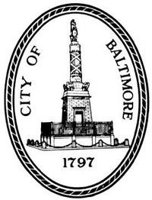
Baltimore City Council Ceremonial Resolution Request

Requests (except condolences) must be received no later than 10 days before the certificate is needed.
Only typed requests will be accepted.
The City Council does not issue proclamations or dedicate holidays. Please contact the Baltimore City Mayor’s office for such requests.

Contact Info Contact: Phone Number: Email: Address:
Method of Delivery:
US Mail (Mailed to above address) Pick up at City Hall
Other:

Resolution Date Certificate is Needed: Date to be Presented: Name of Recipient:

Condolence:
Date of Birth: Date of Death:

Congratulatory:
Resolution Text (25 words or less): IN RECOGNITION OF

INTERNAL USE ONLY. DO NOT WRITE BELOW THIS LINE.

Resolution Number:#
Introduced by: Staff Requesting: Date to be Introduced: Date Request Received:
Presentation:

Deadline is 12:00 Noon, Monday for placement on agenda—NO EXCEPTIONS.
Please forward completed form to the Office of the City Council President.
City Hall Room 400, 100 N. Holliday St., Baltimore, MD 21202
Phone: (410) 396-4804Fax: (410) 539-0647
Email: councilpresident@baltimorecity.gov

Revised 3/3/09 Electronic copy revised 3/3/09

